Project Title

Password Cracking & Credential Attack Suite

Internship Organization:
Unified Mentor.Com

Duration:
6 Months Internship

Year: 2026

Project Report Submitted By
Name: Arshi

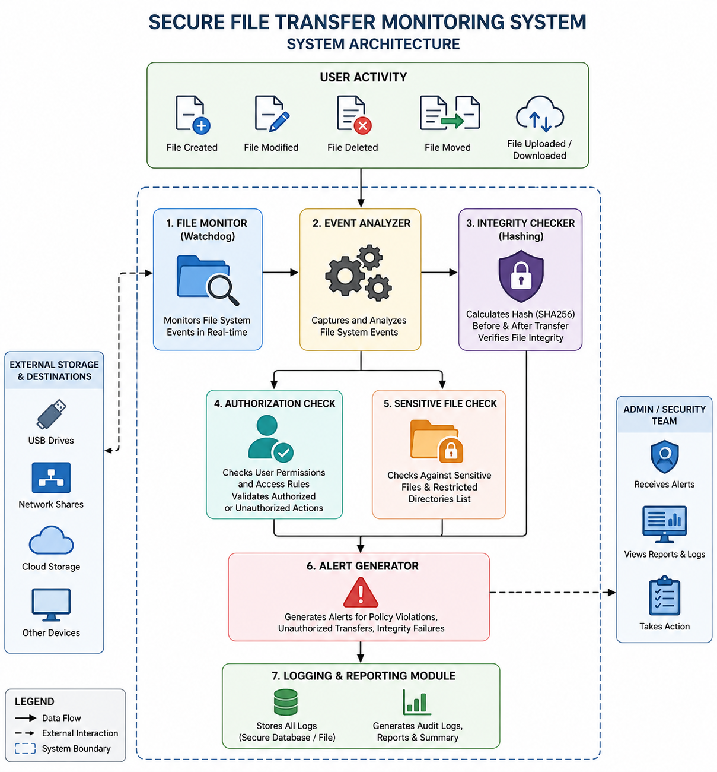

SECURE FILE TRANSFER MONITORING SYSTEM

Chapter 1: Introduction

1.1 Introduction
With the rapid growth of digital data, organizations rely heavily on file transfers for communication and business operations. However, unauthorized file transfers, data leakage, and file tampering pose significant security risks. Cybercriminals and malicious insiders may exploit file transfer mechanisms to steal sensitive information or modify critical files.
The Secure File Transfer Monitoring System is designed to monitor file system activities in real time, detect unauthorized file movements, verify file integrity, and generate alerts when suspicious activities occur. The system helps organizations strengthen their Data Loss Prevention (DLP) and security monitoring capabilities.

1.2 Purpose of the Project
The purpose of this project is to develop a monitoring solution capable of tracking file operations, detecting unauthorized transfers, verifying file integrity through hashing, and maintaining detailed audit logs for security investigations.

Chapter 2: Problem Statement
Organizations frequently face security threats related to unauthorized file transfers, insider attacks, and file tampering. Traditional file systems often lack sufficient monitoring mechanisms to identify suspicious activities in real time.
The major challenges include:
- Unauthorized copying of sensitive files.
- Data leakage through USB drives and network shares.
- File modification without authorization.
- Lack of audit trails for investigations.
- Difficulty detecting insider threats.
This project aims to address these challenges through continuous monitoring and automated alerting.

Chapter 3: Objectives
The primary objectives of the Secure File Transfer Monitoring System are:
- Monitor file creation, deletion, modification, and movement events.
- Detect unauthorized transfers of sensitive files.
- Verify file integrity using SHA-256 hashing.
- Generate security alerts for suspicious activities.
- Maintain comprehensive audit logs.
- Produce detailed security reports for analysis.
- Support Data Loss Prevention (DLP) strategies.

Chapter 4: Literature Review
File monitoring systems are widely used in cybersecurity to detect unauthorized access and data exfiltration attempts.
Several technologies contribute to file monitoring:

Watchdog
A Python library that monitors file system events in real time.

Hash-Based Integrity Verification
Cryptographic hashing algorithms such as SHA-256 generate unique fingerprints of files. Any modification results in a different hash value, enabling tamper detection.

Data Loss Prevention (DLP)
DLP solutions monitor and control the movement of sensitive information to prevent unauthorized disclosure.

Insider Threat Detection
Monitoring file activity helps identify suspicious user behavior and unauthorized data access.
The combination of these techniques provides a strong defense mechanism against file-related security threats.

Chapter 5: Methodology
The system follows a structured monitoring and analysis process.

Step 1: File Monitoring
The Watchdog library continuously monitors designated directories for file events.

Step 2: Event Analysis
Detected events are classified into:
- File Creation
- File Modification
- File Deletion
- File Movement

Step 3: Integrity Verification
SHA-256 hashes are generated before and after file transfers.

Step 4: Authorization Validation
Sensitive files are checked against predefined security policies.

Step 5: Alert Generation
Suspicious activities trigger security alerts.

Step 6: Logging and Reporting
All events are stored in log files and summarized in audit reports.

Chapter 6: System Architecture
The Secure File Transfer Monitoring System consists of multiple components working together.

Components
- User Activity Layer
- File Monitor Module
- Event Analyzer
- Integrity Checker
- Authorization Checker
- Alert Generator
- Logging and Reporting Module

Architecture Flow
User Activity ↓ File Monitor ↓ Event Analyzer ↓ Hash Verification ↓ Authorization Check ↓ Alert Generation ↓ Logging and Reporting

Architecture Diagram
(Insert the generated System Architecture Diagram image here.)

Chapter 7: Implementation

Technologies Used
Programming Language:
- Python
Libraries:
- Watchdog
- Hashlib
- Psutil
Development Environment:
- Visual Studio Code
- Windows Operating System

Modules Implemented

File Monitoring Module
Detects file creation, deletion, modification, and movement events.

Integrity Checker
Calculates SHA-256 hashes for tamper detection.

Authorization Checker
Verifies whether file movement is authorized.

Alert Manager
Generates security alerts when policy violations occur.

Reporting Module
Creates logs and audit reports.

Working Process
- User performs file operation.
- Watchdog captures event.
- Event Analyzer processes the activity.
- Sensitive file checks are performed.
- Hash integrity is verified.
- Alerts are generated if violations occur.
- Event is recorded in logs.

Chapter 8: Results and Screenshots

Result 1: File Creation Detection
The system successfully detected file creation events.

Result 2: File Modification Detection
The system recorded file modifications and generated logs.

Result 3: Sensitive File Transfer Detection
Alerts were generated when sensitive files were moved.

Result 4: Integrity Verification
SHA-256 hashing detected file changes successfully.

Result 5: Audit Report Generation
A complete audit report was generated summarizing all activities.

Screenshots
Insert:
- Monitoring Tool Running
- File Creation Event
- File Modification Event
- Sensitive File Alert
- Audit Report Output

Chapter 9: Challenges Faced
During project development, several challenges were encountered:
- Real-time monitoring of large directories.
- Identifying authorized versus unauthorized file movements.
- Handling multiple simultaneous file events.
- Efficient storage of audit logs.
- Detecting suspicious transfers without false positives.
These challenges were addressed through optimized event handling and structured logging mechanisms.

Chapter 10: Future Enhancements
Future improvements may include:
- Email alert notifications.
- SMS-based security alerts.
- Cloud storage monitoring.
- USB device tracking.
- Machine Learning-based anomaly detection.
- SIEM integration.
- User Behavior Analytics.
- Real-time security dashboard.
- Automated incident response.
These enhancements will improve detection accuracy and response capabilities.

Chapter 11: Conclusion
The Secure File Transfer Monitoring System successfully monitors file system activities and provides visibility into file movements within an organization. The system detects unauthorized transfers, verifies file integrity using SHA-256 hashing, and generates alerts for suspicious activities.
The project demonstrates the practical application of cybersecurity monitoring techniques, Data Loss Prevention strategies, and integrity verification mechanisms. It enhances organizational security by providing real-time monitoring, detailed audit trails, and incident detection capabilities.
The developed solution serves as an effective tool for protecting sensitive information and improving overall cybersecurity posture.

References
- Python Software Foundation. Python Documentation.
- Watchdog Documentation.
- National Institute of Standards and Technology (NIST).
- OWASP Security Monitoring Guidelines.
- Cybersecurity and Infrastructure Security Agency (CISA).
- Data Loss Prevention Best Practices.
- SHA-256 Cryptographic Hashing Standards.
- Microsoft File System Security Documentation.

